LABORATORY PTOJECT GUIDELINES

CS M171L & CS 117

Use these guidelines as a template for writing your lab projects. A laboratory project is a highly formatted technical document. It requires a very different style than the prose you learned in humanities writing. Clarity is of primary importance, eloquence is secondary. For additional help see the TA for references.

Title Page
Name, course, quarter, date, partners names, lab title

Abstract
Short and concise description of the goals and the results obtained in Lab experiments.

Table of Contents
All sections should be numbered, as should all pages. A table relating section number to page number should appear at the beginning of the project.

List of Figures
All figures should be numbered. A table relating figure numbers to page numbers should appear at the beginning of the project.

Introduction
What are the goals of the experiment, expected outcomes, and general circumstances surrounding the experiment.

Theory
Explain the theoretical basis for the lab experiment. Since the goal of the experiment is often to observe the correlation between theory and the real world, it is suggested that the theory section be written before attempting the lab exercise and includes all the necessary formula Your time in lab will be much more efficient and enjoyable if your goals are clear.

Don't forget to cite all references! (For theory section you can use completed prelab as a part).

Equipment
The equipment list with ID numbers is used for verification and reproduction purposes. The reader of your project should be able to reproduce your experiment based in the information you include. Also, sometimes erroneous results can be traced.

Method
Method is of primary importance in proper lab technique. Experiments must always be carried out in an orderly, precise fashion. When attempting to verify or question your results, the astute reader will check the method to see if you forgot something important. There is no shame in making a methodological mistake, only in failing to correctly document the method. Undocumented results are useless for it it's impossible to verify their correctness. (It is suggested to apply to the project method given in the handout).

Results
List in unbiased fashion the results of the lab experiment. Consider both qualitative and quantitative results. Use plots, charts, graphs, pictures and other visual representations whenever possible. Fully label all plots and do not forget to present the dimensions of the plotted values. (It is necessary to apply to the project row data given in the handout, and signed by TA).

Error Analysis
When physical readings are taken this section should be included to document the precision and possible sources of error and calculations made to get the resulting errors.

Discussion

This is the most important section of the lab project. It shows the skill of the author in terms of his/her ability to correctly interpret the results of the laboratory exercise. Attempt to explain all deviations from expected results here. Use your head!

Conclusion
What did you learn in this experiment? Were you surprised by the results? Did you form an overall model of the process being studied? Any suggestions for improvement of the exercises are welcome here.

Appendices
Any raw data tables or other material not belonging in the body of the project is included at the end. Make sure to reference the material or the reader will never look at it!

References
Project for CS M 171L & CS 117 may use any style of referencing, as long as all sources are cited. Generally, references will be used most in the theory section.

General Tips for Creating Great Lab Project

- It's not enough to say "it worked" or "theory is correct" or "our results support the theory." Need to support observations with description, (qualification and quantification). This process is called analysis - it should be the majority of your project.

- The quick and easy guideline to a successful lab project is “MAC” - Method, Analysis, and Clarity. If you've got these, you'll be understood, if you don't, you won't.

- Plot your output whenever possible. Spatial information processing takes place at an easier cognitive level than symbolic interpretation; that is, a picture is worth a thousand words.

- Be precise and consistent when making plots. Always use consistent scales, label your axes, etc.
STYLE GUIDE

The writing style required for technical writing is very different from that used for expository prose. Most high school English courses encourage a flowing, conversational style imbued with personality and demonstrating ones command of the language.
For a piece of writing, which is based on opinion, this may be fine. Technical writing, however, is based on FACT and ANALYSIS. The style is clear, simple, and concise. Flow in technical writing is derived not from transitional phrasing but from a clear and orderly progression of ideas. When done correctly, the act of writing is CRITICALLY IMPORTANT IN THE LEARNING PROCESS.

"What? Writing helps me learn? I thought I learned first, then just wrote it down..."

Sooner or later (hopefully sooner, now that you're in this class) you will learn the value of the ACT of writing (many of you may already know). Inside one's head it is easy to think "sure, I understand," but only when we attempt to establish the clear, logical flow of ideas on paper do we see the holes that remain in our understanding.

An example will serve to illustrate:

Experiment explanation written in standard conversational English:

“In step 5 we took the spectrum analyzer and measured the frequency of the waveform. The result was a square wave which looks like this:

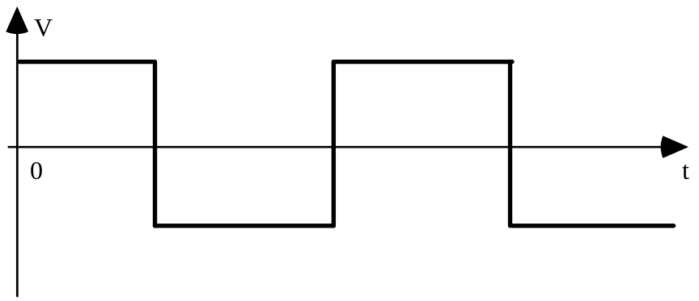

We found that the steepness of the edges varied with capacities which is in accordance with theory, therefore the theory is correct”.

This hypothetical example is typical of many lab project s received from CS M
171L students (before they "saw the light") Keeping in mind that the goal of technical writing is to communicate unambiguously factual results, observations, and analysis, here are some questions that could be asked about the data presented in this paragraph:

• What sort of spectrum analyzer?
• What method did you follow to measure frequency?
• A spectrum analyzer measures many frequencies, which ones did you measure?
• What data points were taken?
• What is the precision and accuracy of the recorded data points?

(And that was just the first sentence!)

• What does the squiggle on the page represent?
• If it is an oscilloscope trace, what are the voltage and time units?
• What is the scale on the scope?
• The period of the illustrated waveform does not appear to be consistent, is this really a "square" wave?
• What is the deviation from a "true" square wave?

(That was the second sentence)

• Do the observed deviations agree with theory?
• If so, is the amount of deviation consistent with theoretical prediction?
• What is the amount of error allowed for in the theoretical prediction?
• How would you explain the deviations from theory?
• Define "steepness"?
• Can you really say you have proved a theory correct with a single experiment?

As you can see, the original explanation is woefully incomplete. Much remains to be said to completely and adequately explain the experimental result. Fortunately, the process of technical writing naturally asks questions like those above.

Technical writing is an iterative process by which a written draft is continually revised, each time asking

1) "What do I mean by this?"
and
2) "Did I really say that as clearly as I could have"?

The first question usually results in the document being expanded as further explanation is given. The second usually results in repetitive or wordy explanations being reduced to more clear and precise representations of meaning.
To go back to our example above, we may note that the questions relate to four of the most important aspects of technical documentation:
Method: what was done, how was it done, what was used to do it and what was the precision and accuracy of the measurement.

Results: clearly document the exact data collected. Include units, scales and error estimates.

Observations: record all observations, without bias or opinion. Observations are information which is in addition to data collected and relates to environmental factors, experimental conditions, equipment functioning, etc.

Analysis: discussion of what you saw versus what you expected. This is the most important section in which to have a clear, logical and orderly procession of ideas.

Now, let's rewrite the example paragraph using better technical style:

Example:

Method
“Spectrum Analyzer #2 (HP Model 5505A) was used to record the frequency spectrum of a 10 kHz rectangular wave generated by Function Generator #1 (Wavetek 3301). The experimental setup is shown in Figure 1.”

Results

“Figure 2 is a hand drawn representation of the waveform observed on the oscilloscope. Data points taken from the drawing using a ruler were used for calculations and are included in Appendix A.

Using the data from Appendix A, the waveform was found to have a frequency of 510 Hz (+/- 2 Hz). Calculations and error determination are shown in Appendix B. The slope of the edges was determined to be vertical within the limits of measurement without capacitance. As capacitance was added, the slope increased to a minimum of 5.27 Volts/sec at 20.772 µF. The rate of change of slope is calculated to be .00127 Volts/sec/sec (+/-.00001 Volts/sec/sec). Calculations are shown in Appendix B.”

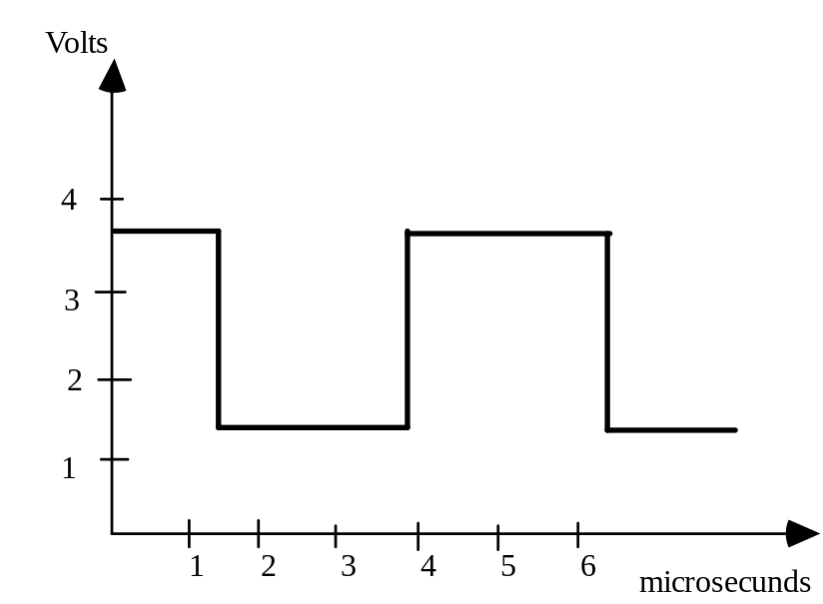

Figure 2. Oscilloscope trace of Part A waveform

Analysis

“According to the RC Model of the transmission line, the rate of change of slope should be .00035 Volts/sec/sec as shown in Section 2 (Theory). Our measurement is off by a factor of three but is within the same order of magnitude as the theory prediction. Since resistance values used for the calculation were taken from manufacturers specifications and not from actual experimental measurements a 2% (manufacturers specifications) error is introduced. Other sources of error could include corroded connectors, uncalibrated equipment, and imprecision in the transcription of data by hand.”

“In later analysis, it was postulated that the aluminum connectors could have been a large source of error. A second experiment was conducted in a follow-up session which showed as much as 500% variance in readings when different conductors were used. It is therefore concluded that our experimental findings agree with theoretical predictions within the limits of measurement accuracy.”

Lab Project #1 -- SAMPLE
Signals In Time And Frequency Domains
CS M171L (CS 117)

Name: _________________
Lab Partners: _________________
Date of Lab: _________________

Abstract
In this experiment, we compared the frequency domain representation of several periodic signals to predictions based on Fourier Series. We performed a Fast Fourier Transform on periodic signals using an application in LabView. Our results sinusoidal signal correspond with the theoretical predictions, but our measurements for square waveform signal differed from the predictions due to duty cycle uncertainty. The widest bandwidth we measured was for the rectangular signal, and this was 25 times the fundamental frequency. We found that adding a DC offset does not affect the frequency domain representation. Changing the signal amplitude or frequency of the periodic waveform caused a changes in the amplitudes or frequencies of the frequency domain representation.

Introduction
In this lab, we learned a great deal about using the equipment in the laboratory. We used the Digital Oscilloscope to verify that all waveforms were properly generated, with the correct amplitude and duty cycle. We used virtual instruments in LabView a spectrum analyzer. These instruments automatically calculated the DC Offset, power, effective bandwidth. We measured the amplitude of each peak in the spectrum up to 8 times the fundamental frequency. (Put here anything you want to add that describes the lab, without worrying about brevity as you do for the abstract.)

Theory
Write your own theory section that covers this material and any other material you feel is needed..

Method
Enter the method here. Entering the method, you have to re-draw the connection diagrams, you must accurately reflect the experiment procedure.

Results
Prior to the lab, you have had prepared all theoretical predictions in the “Raw Data and Error Estimates” and lab handout completely filled out. During the lab, you have used these pages to fill in the results, error estimates, and error calculations for each measurement. Do not change anything on these sheets after you have left the lab. (You can correct it If there is an easily correctable mistake in your data or error estimates (a misplaced decimal point, a missed digit, or an inverted sign), do not correct the original pages).

(Before you leave the lab, be sure that the error of all your measurements falls within the span of your error allowance. If it does not, either redo that part of the lab or determine the source of the additional error in your experiment.)

You have to rewrite your results on a new copy of the “Raw Data and Error Estimates” pages of the lab handout (with handwritten notes about simple corrections). You must also submit your original data pages as an appendix to your lab project.
You can write a paragraph in the results section explaining the mistake and how you corrected it. If there are more extensive problems with your data or error estimates, you should address them in the error analysis or discussion section.
You may print your results in tables that you create for your lab project. If you create tables, make sure you present only the original data and error estimates (write a paragraph about simple corrections if necessary).
.

Observations
Here you can express anything interesting you saw that is not quantitative. If there was something during the lab that you think might have impacted your results (even if you are not sure exactly how) express it here. If you had trouble with the lab equipment, or if you think the equipment might have been faulty, express that here also. If your observations are about additional sources of error that may have caused your results to exceed the error allowance, you must discuss these sources of error in the error analysis section. If you made observations about possible sources of error that did not cause your results to exceed the error allowance, you can just mention them here.

Error Analysis
Here you should describe the calculations of error allowance that you performed in the “Results and Error Estimates” section of the lab handout. List the sources of error in each part of the experiment. If the error of any measurement is greater than the error allowance, you must discuss what additional sources of error were present (or whether some source of error may have been stronger than you estimated).

For the bandwidth calculations, don’t take a percentage error, but discuss any discrepancies between the theory and your results. What could cause the result to be different than the expected? There’s no percentage error you can easily calculate, but you still need to address error in the bandwidth measurement part of this lab.

Discussion
Discuss each part of the lab project. It might be a good idea to put a separate paragraph for each part with the name of that part. For instance:

Part A
The sinusoidal signal frequency domain representation was composed of only one peak at the same frequency as the sinusoidal waveform. et cetera

Be sure to ANSWER ALL QUESTIONS in the lab project. If you have trouble understanding the questions, or don’t feel you can answer them based on your knowledge, contact the TA or professor. If you can’t reach them, answer the question to the best extent of your knowledge, but include some kind of answer in your project.

Conclusion
Include anything else here you want to say about the lab. If you want to comment about anything in the lab, or suggest ways to improve the lab, please mention them here. This section is an extension of the discussion, so if there’s something you want to include that you think doesn’t belong in the discussion (but you’re not absolutely sure), put it here.

Appendix

You must submit corresponding original Protocol pages as an appendix to your lab project.

